ThoughtSpot

*Search on “Note” to see notes

# 1. Welcome to ThoughtSpot

[Welcome to ThoughtSpot Cloud](https://training.thoughtspot.com/welcome-to-thoughtspot-cloud)

**Overview**

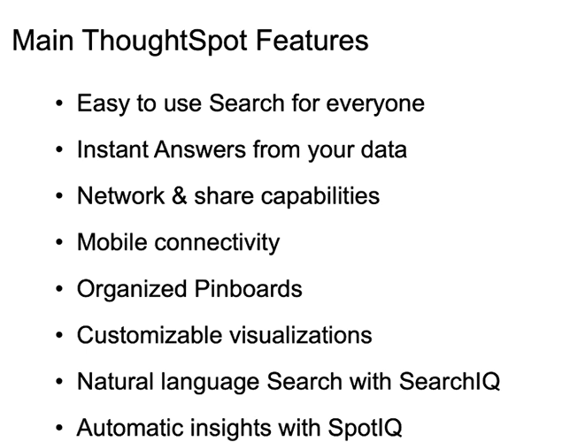

**Goal :**

* data analytics fast; no advanced tech training or knowledge; simple use xperience;use Spot IQ AI search
* Socialized and shared. Single version of truth; mobile ready;
* Create personalized results;
* Connectivity to many sources
* Easy to use;

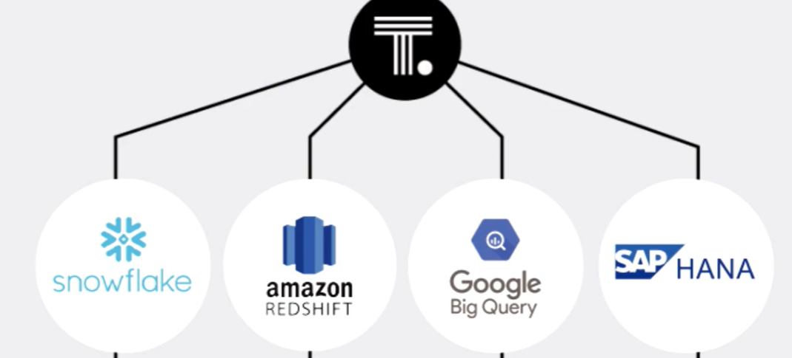

Search(auto returns viz)-customize and drilldown on parameters (liveboards)

**\*Note** -spot iq : easy way to see suggestion based on AI whern we don’t know what to ask

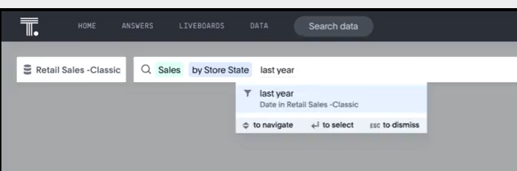

## Features

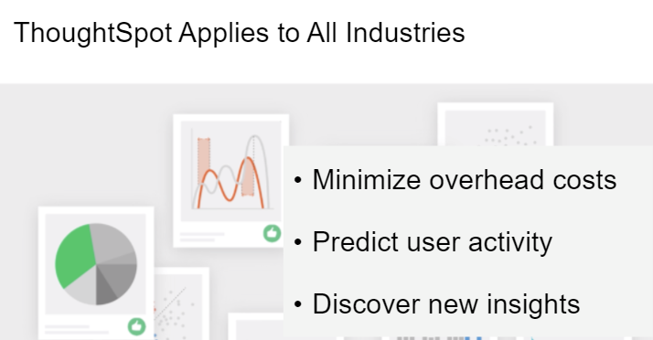

# 2.Intro to Search and Answers

|  |
| --- |
| Course Objectives |
| * Navigating ThoughtSpot |
| * Understanding Data Sources |
| * Searching in ThoughtSpot |
| * Components of Search |
|  |

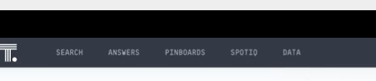

-tab access can vary

## Navigation

Main landing page:

* Search
* Favorites
* Recently viewed
* Trending and popular (Load more..)
* Did you know?(Spot IQ inisghts)

**Search :**(Search from landing page or use tab);

Real time

Save the ones you like

**Answers** : saved search

*Note any page other than home page has option to search answers and liveboards

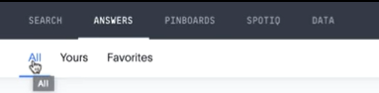

**Pinboard**: like dashboard( list of related answers)

* Share pinboard to others
* Can be favored
* Can add or remove answers from pinboard

**SpotIQ Analyze:**

Open any answers ,right click and select Analyze

**Data**

1)excel can be imported for Business users and it present under tables

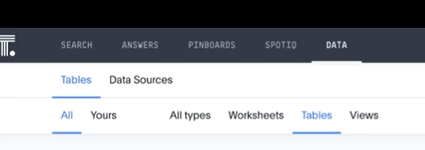

**Help:** docs and keyword search

## Understand data sources

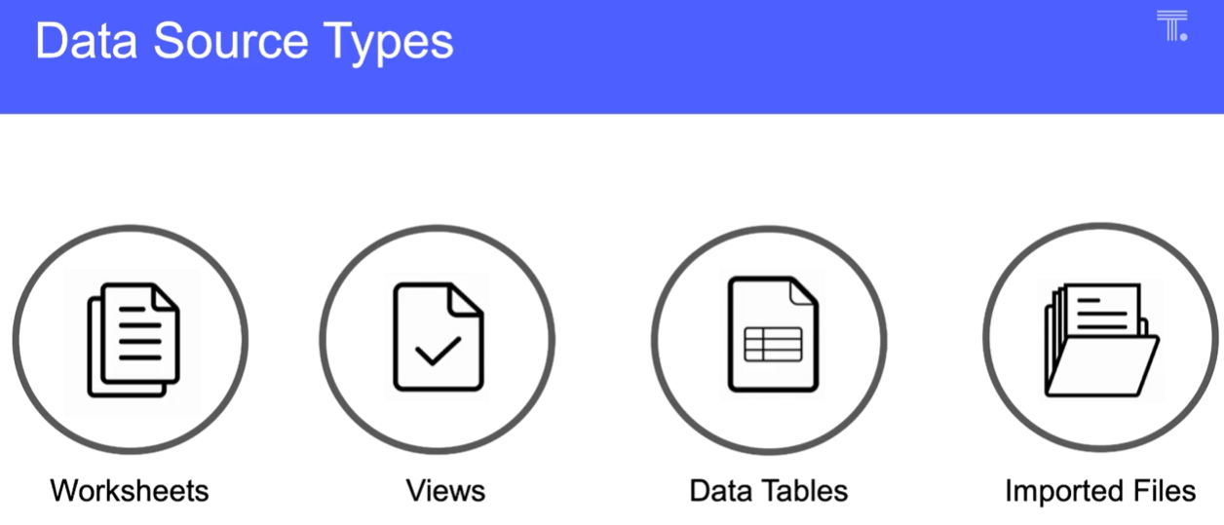

*Note

Worksheet: collection of related tables optimized for search (data tables or imported files; group tables together; access control; column level security;)

Views:search on top of a search

Data tables : raw tables

Imported files : uploaded through web browser

To select source: Choose sources

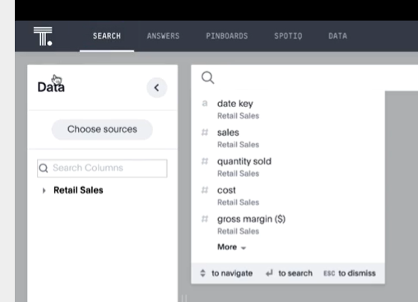

**\*Note :** Stickers for data sources(setup by admin)

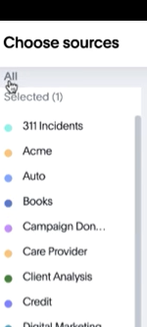

Hover over the field to see the datatype, sample data values and description abou the data field.

*Note wathclist :monitor key metrics

=> add metrics change order of display

## Search

**Key terms:**

* Attributes and measures
* Data values and filters
* Keyword : preconfigured (like average, last month, top and botton) – keywords list can be found under help
* **\*Note** Pro Tip(measure in green, attributes in blue, fitlers in grey)
* Searched happen in context of data source
* Start with measure, attribute (one measure, twp or more attributes, and filter) then add keyword(last month)
* Search IQ : ‘Ask questions and get answer;language option is avaibale

## Answers

* **\*Note** Resuls always have recent data

## Quiz

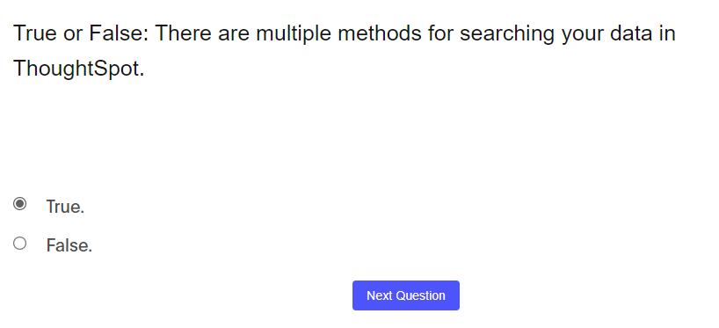

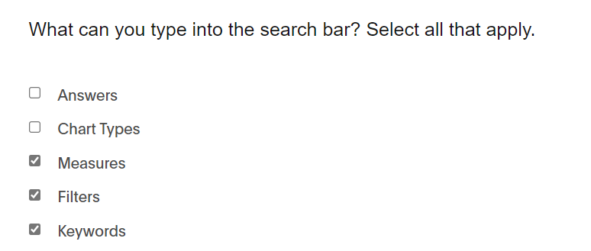

(Click on three dot is not a correct answer)

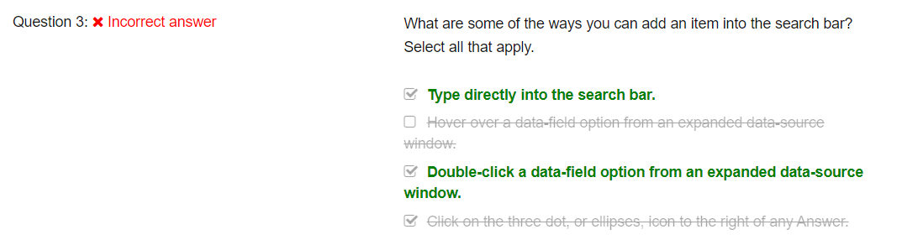

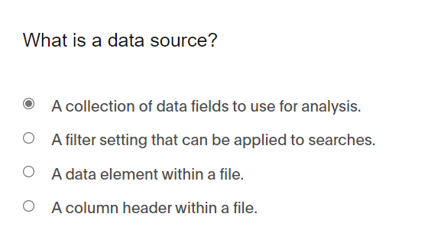

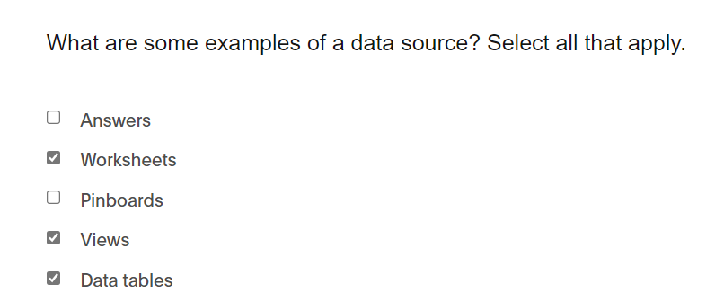

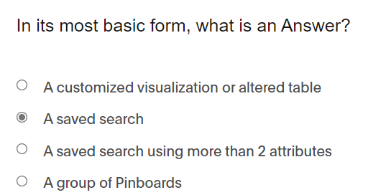

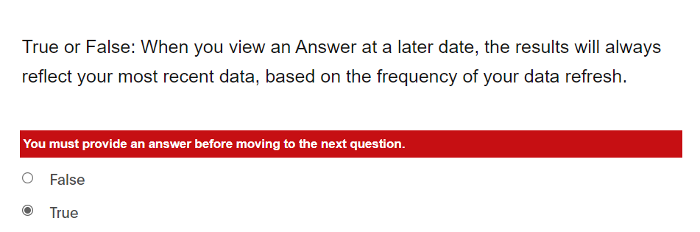

# 3.Filters

## Methods to filter

* **\*Note** Individual vs. bulk filters
* Edit filters on existing puinboards

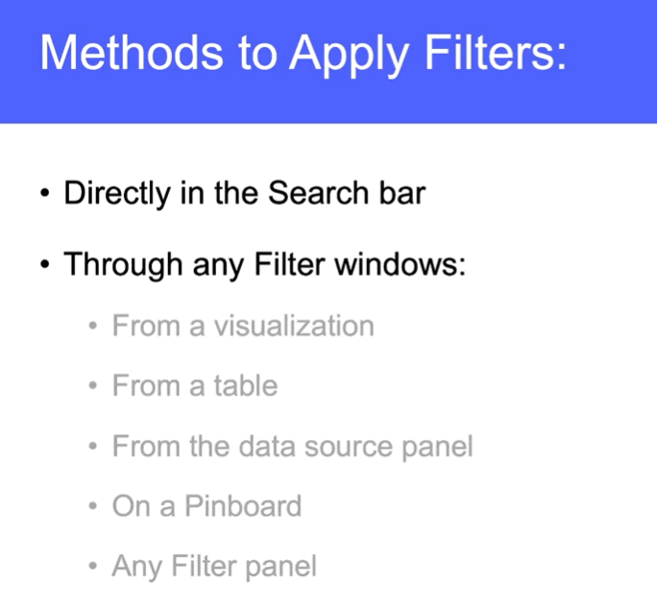

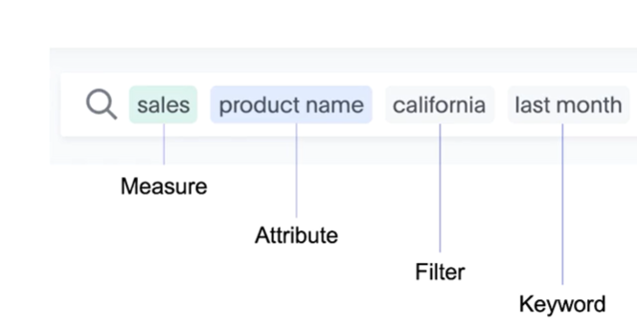

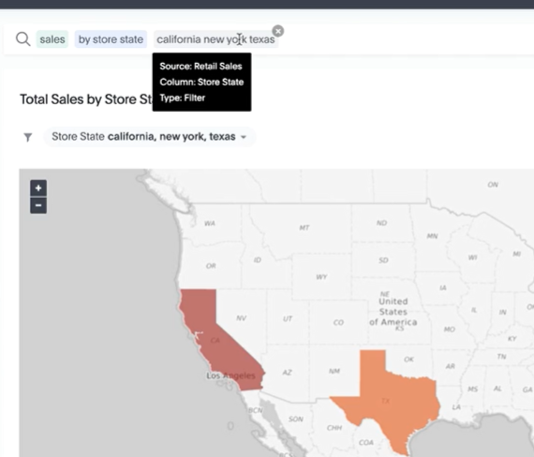

**Through filter panel**

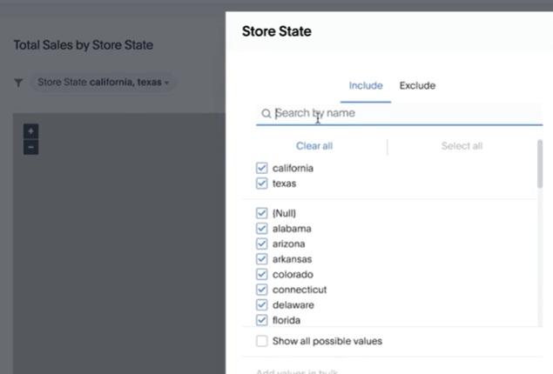

*NOTE: “Show all possible values” are applied only when working with “cascading filters”

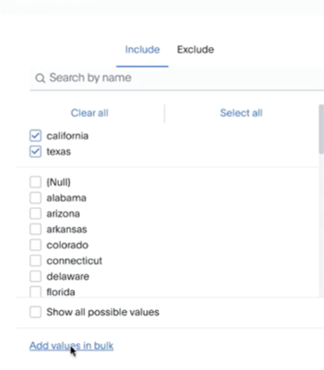

*NOTE : can add values in bulk by pasting from external source(csv)- use when 100+ items need to be used(separate by comma, semicolon, new line character)

*From table view to filter

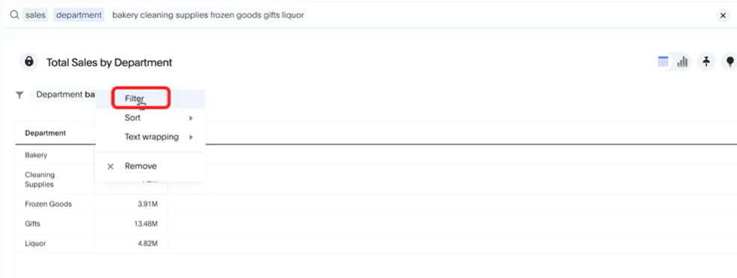

**\*Thorugh data view**

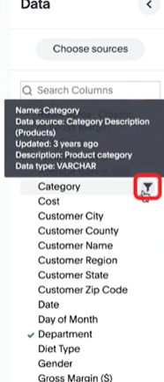

From pinboard

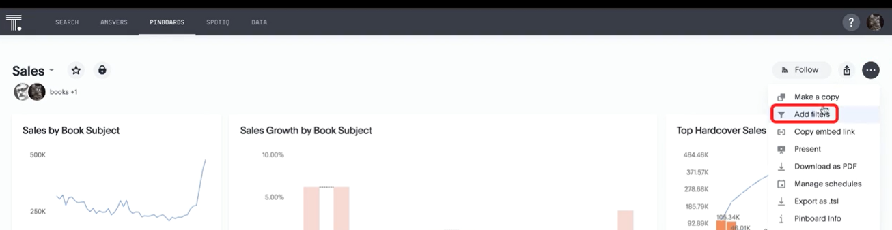

## Filter Types & options

* measure and operator filter

**option1:**

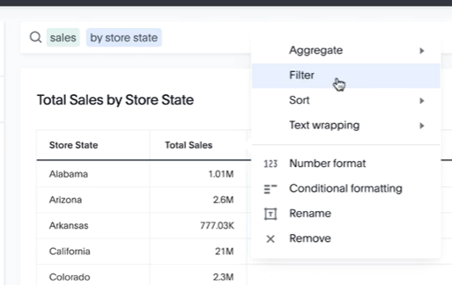 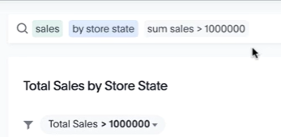

**“*Note option :add a condition”..use condition > and <**

*we can use vizbased on axis attributes to apply measure filter

*Note Keywords for filter:

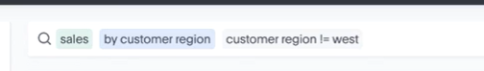

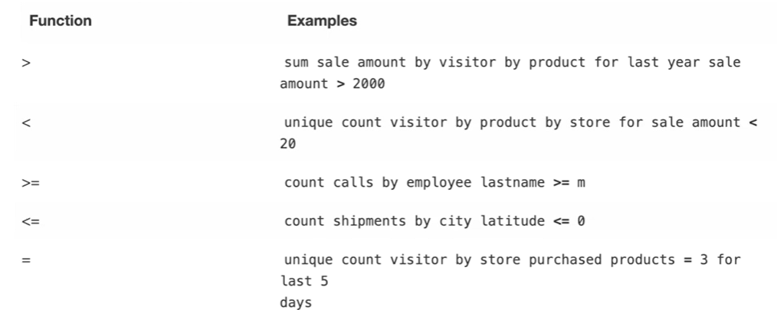

## Time & Date Filters

**Objective:**

* Time interval
* Time buckets
* Time ranges
* Absolute/dynamic values
* Date keywords

Interval : basic term for attribute (hourly, daily, quarterly,..)

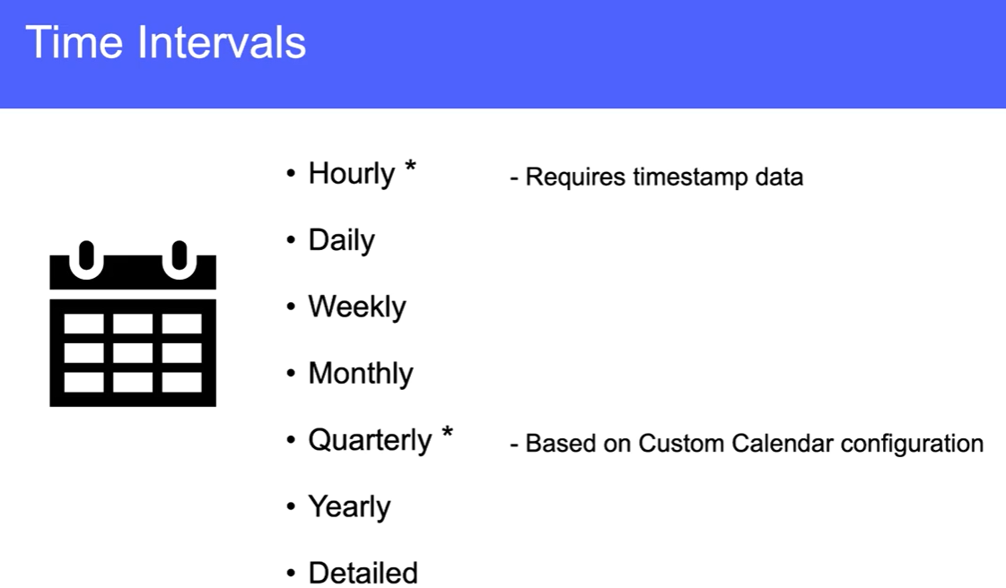

*Note Hourly : is available only when timestamp fields

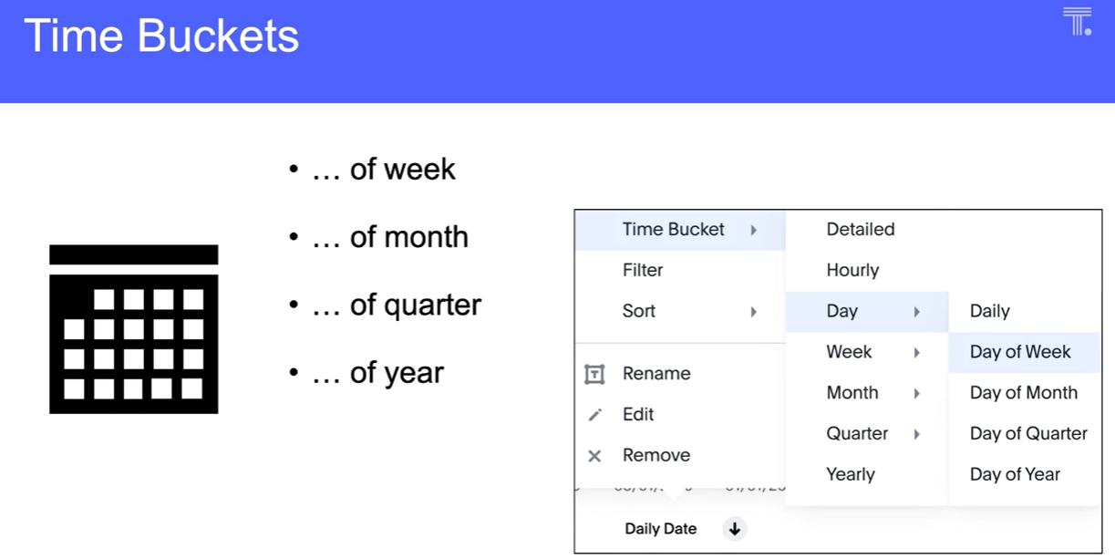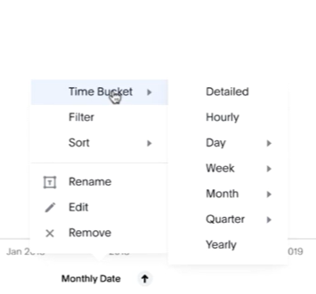

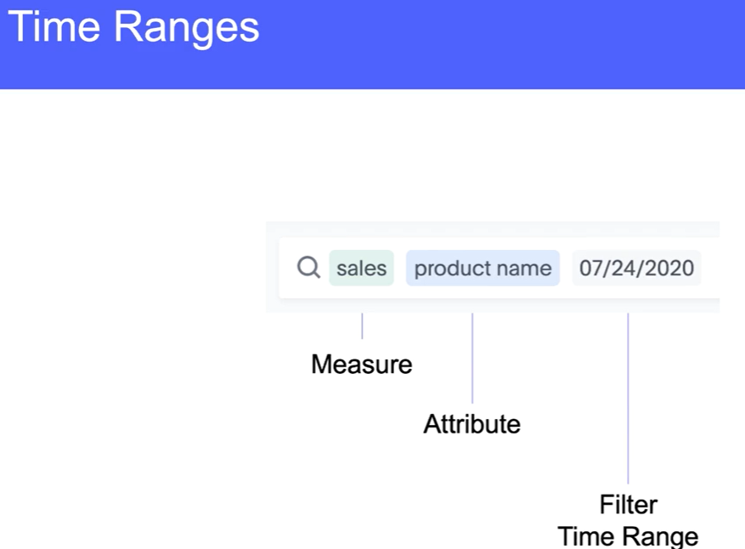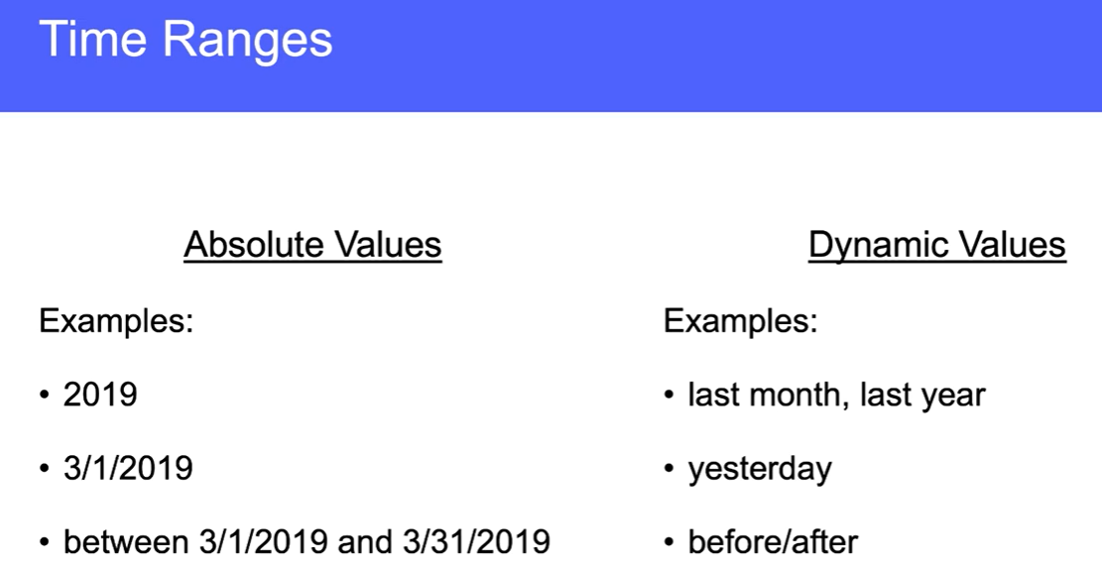

**\*Note cascading Filters**

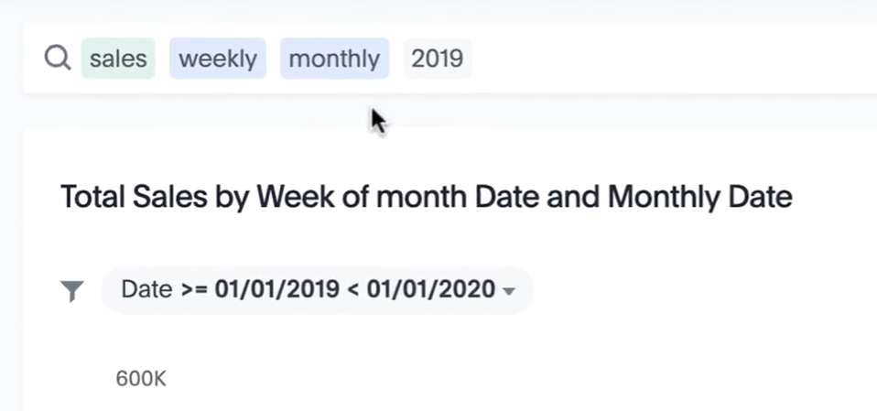

*Note “2019 is abslute search” vs. “last year” makes it dynamic(assuming we are running this in 2021)

### **Use Case: YOY growth**

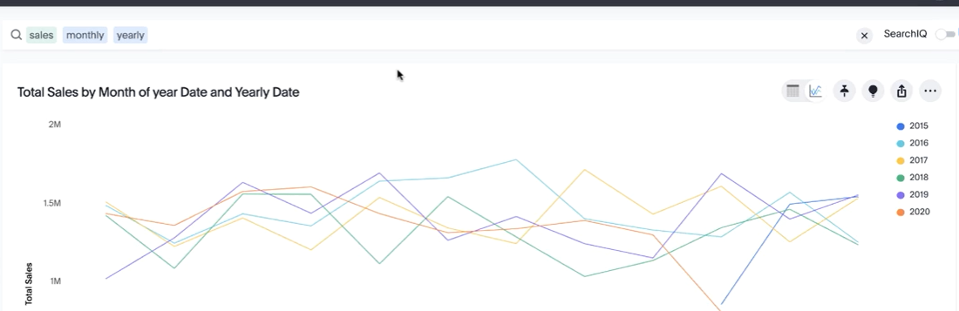

## Filter Quiz

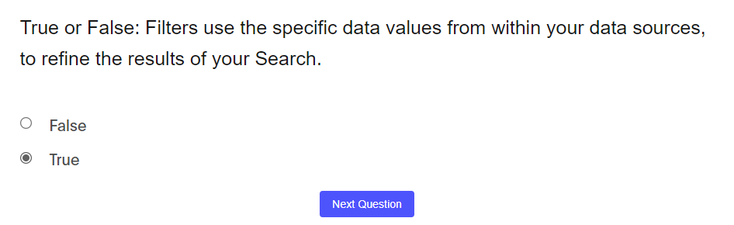

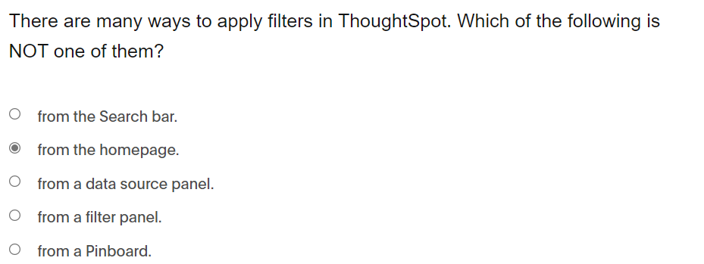

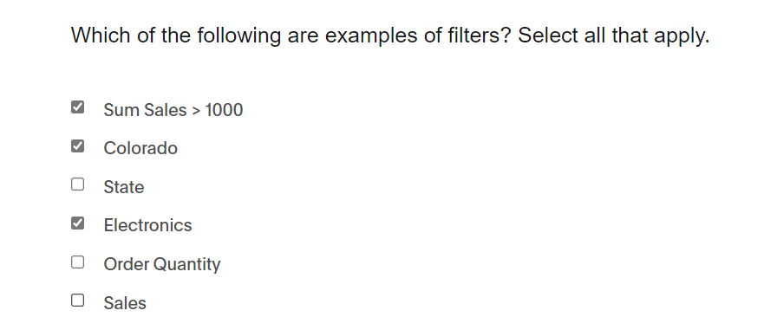

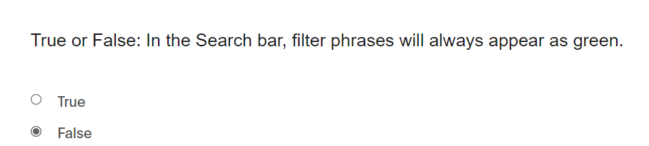

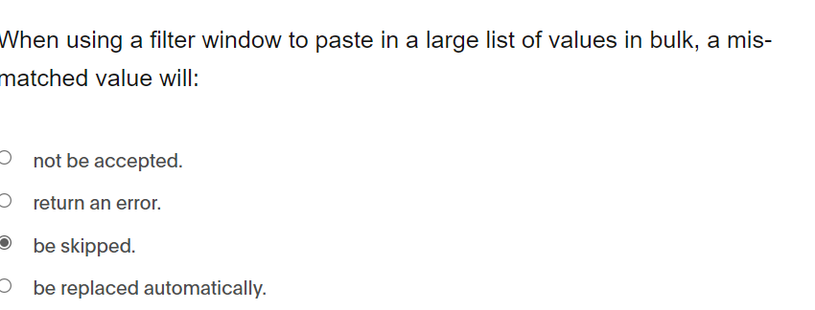

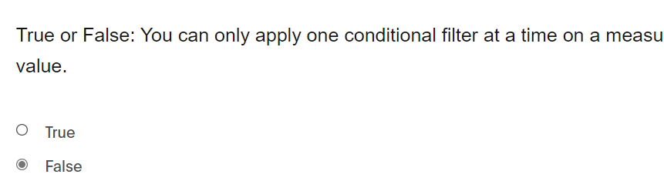

Calendar date picker is not an option

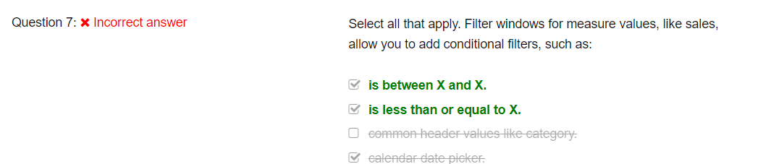

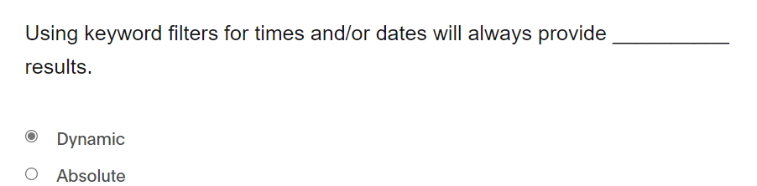

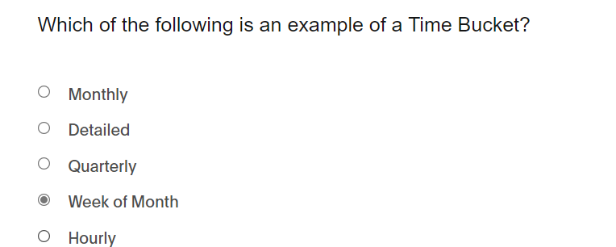

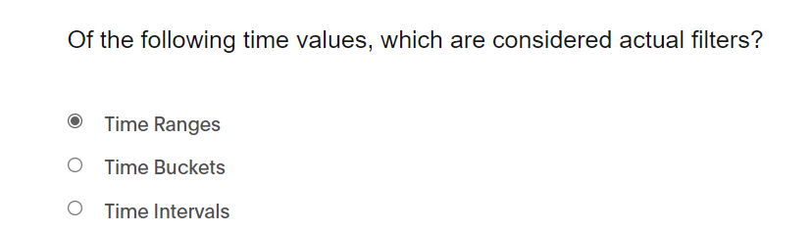

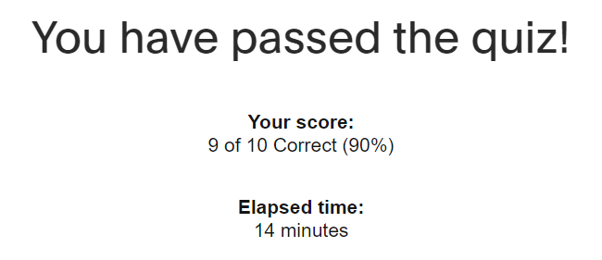

# 4.Keywords

## Agenda:

* General Keywords
* Date and Time Keywords
* Text Keywords
* Number Keywords
* Period Keywords
* In Keyword

**Using keywords:**

* **Predefined terms**
* **Acts as filters**
* **Categories**

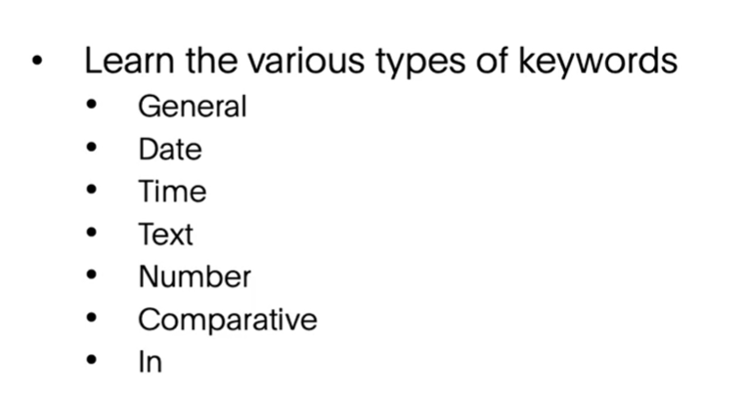

## General keywords:

Top, Bottom, Sort (default to 10 top/bottom)

## Date keywords:

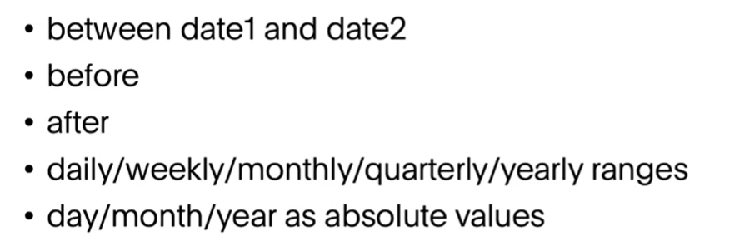

**Samples**: last 3 days, next, this , month **ago**, **year over year**,growth over a period of time

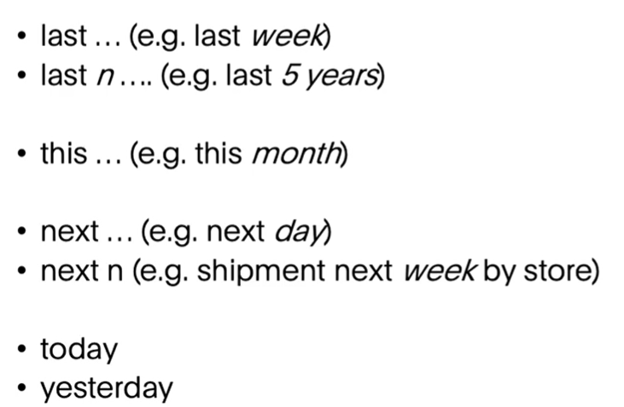

## Time keywords:

Same as date

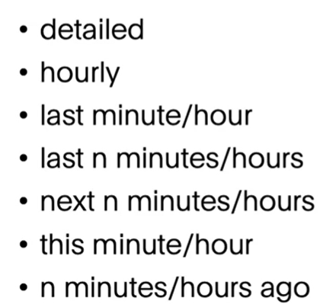 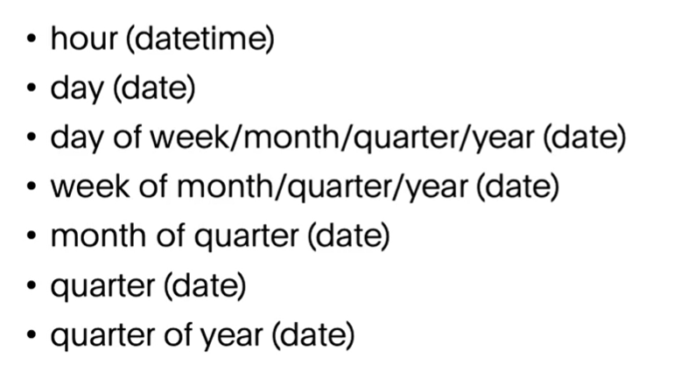

## Text keywords

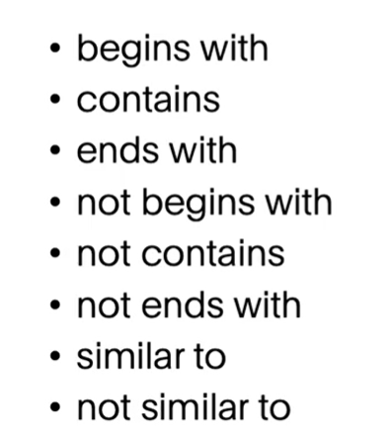

## Number keywords

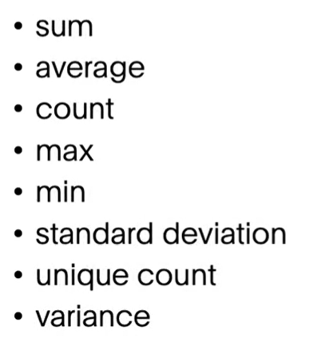

## Comparative keywords

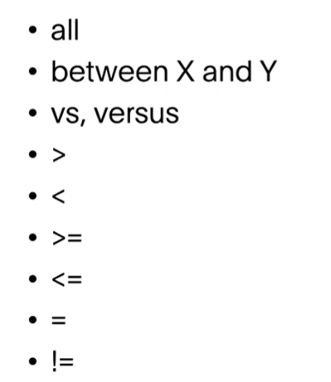

## Nested search

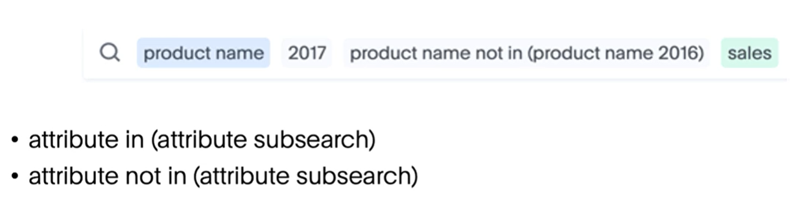

**Use case:**

* **Top 25 * store name *by sales* year to date**
* **Top 5 Department by age group**
* 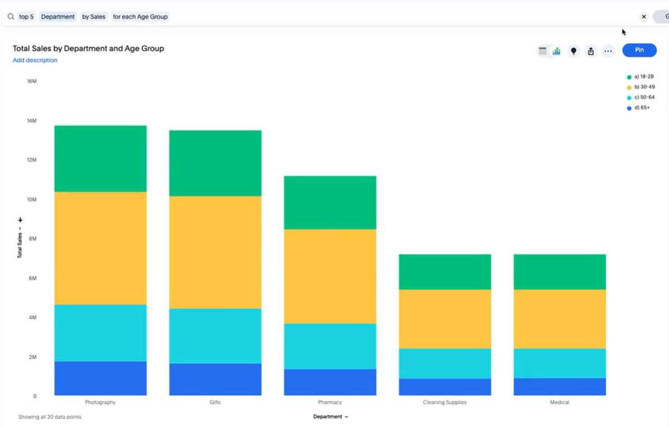
* To note, when you add two categories (age group and income sector), we see 6 department..rememberit means dairy is top 5 for atleast one house hold range

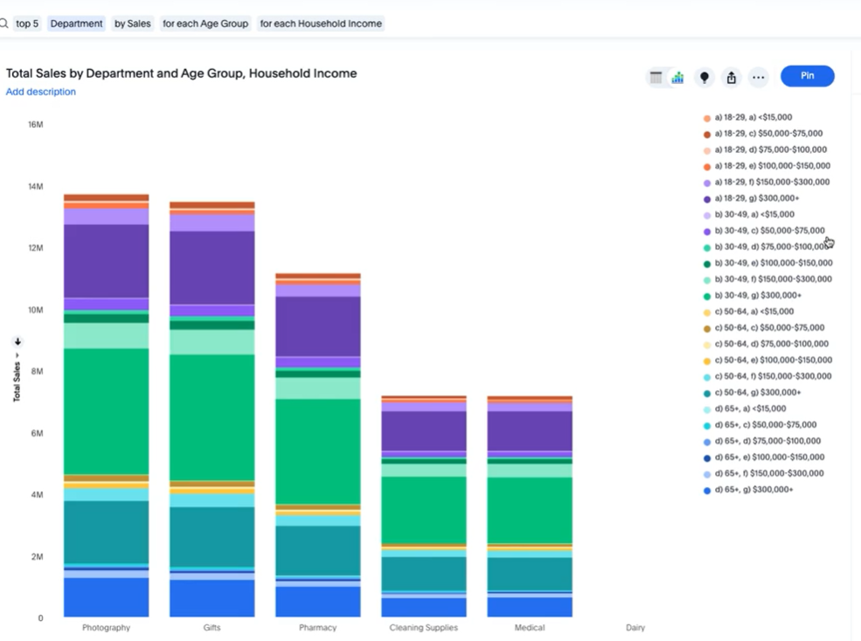

## Keyword quiz

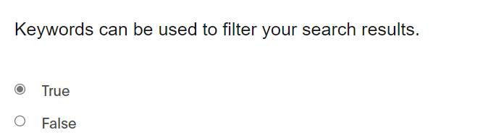

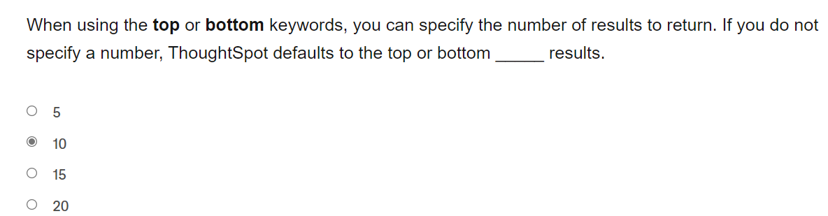

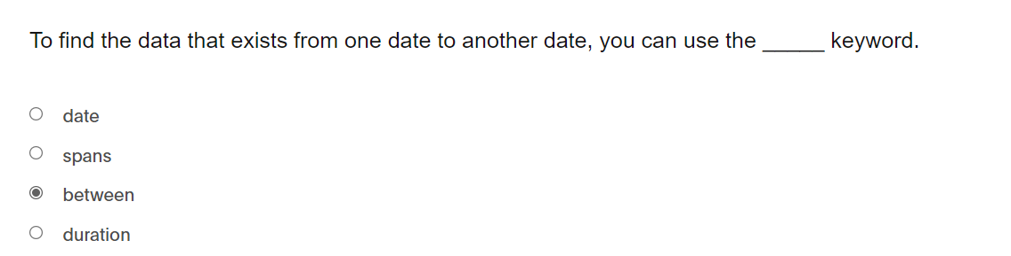

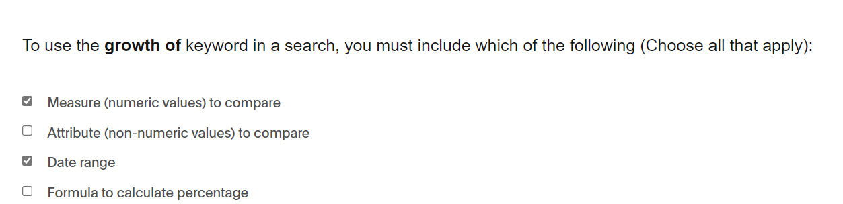

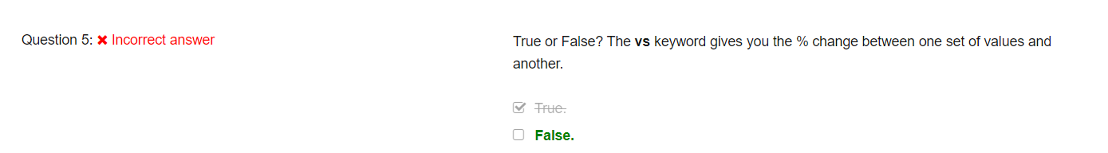

# 5.Liveboards

* Open existing Pinboards
* Create new Pinboards
* Editing the Pinboard layout
* Adding a Filter to a Pinboard
* Using Explore mode
* Using Present mode

**Creating liveboard**

1. Lock sign in liveboard to request access from owner to edit
2. “pin” to Create or add to liveboard
3. To “pin” KPI ,use “search data”> goto setting and select “Column summary”.select “pin” in the summary tile
4. Drag and drop to rearrange
5. To resize, select “eclipse//3 dots” and choose the layout on the botton 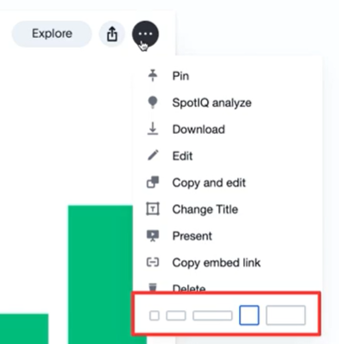
6. To drilldown,select right click and drilldown; to drill up , use blue arrow on the bottom right of the chart
7. Liveboard filters overrides viz filters (when filters are coming from same column, if different column, both filters will be applied)
8. Can share

## Explorer mode

**UBR : Usage based ranking**

to play with viz of the liveboard (hover over to see the viz)

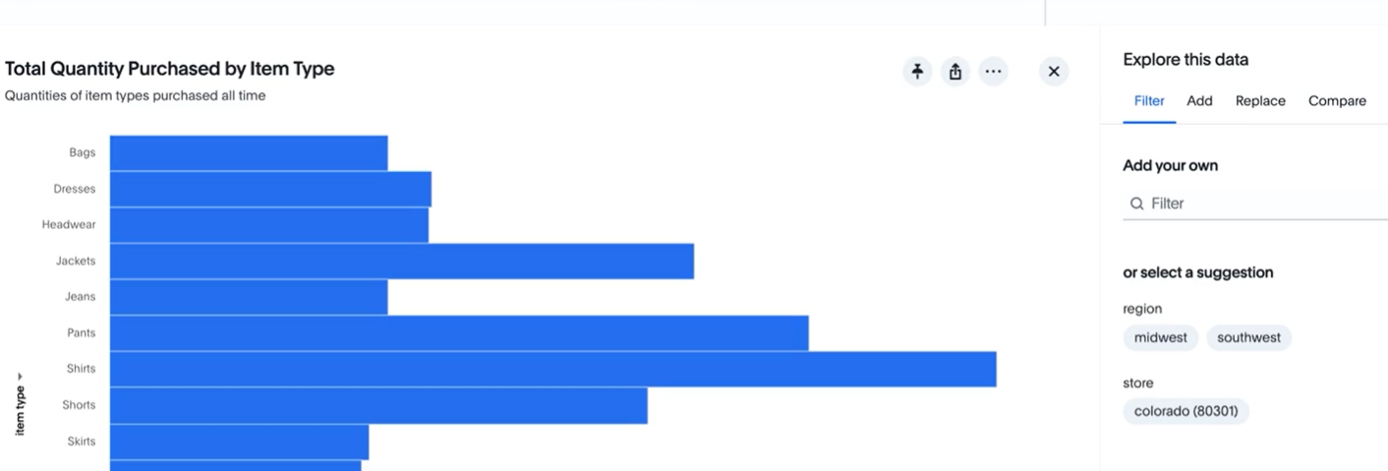

## Liveborad Quiz

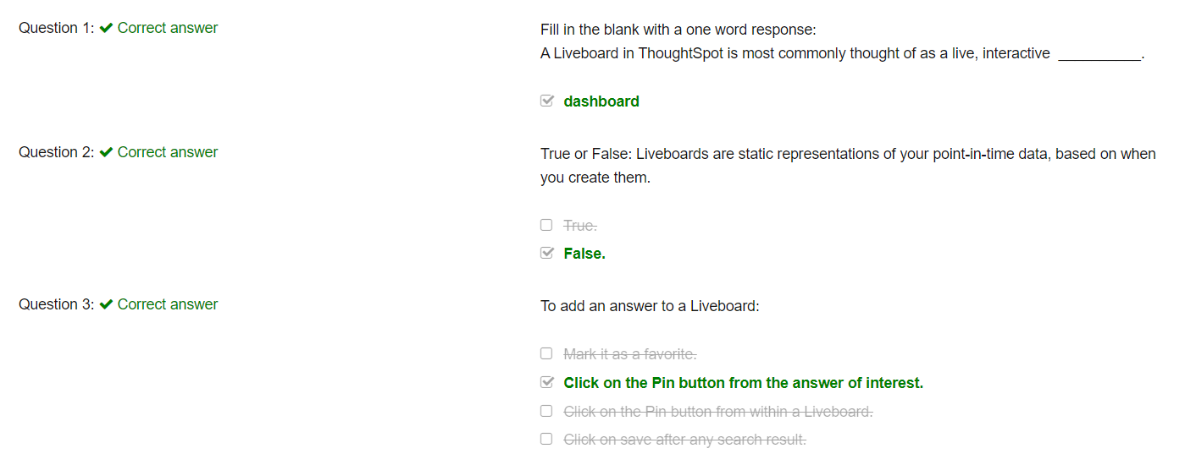

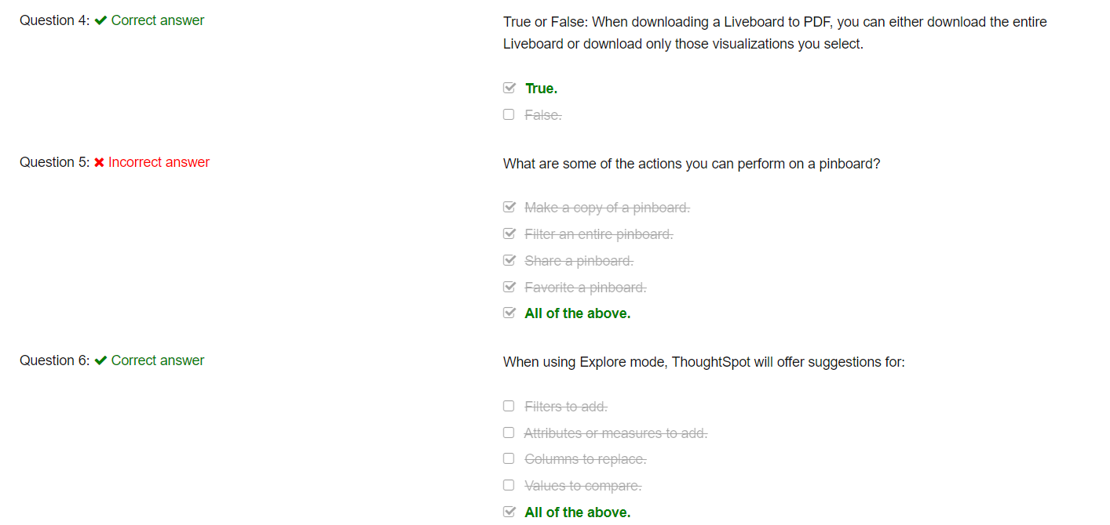

-

# 6.Customizing charts and visualizations

**Agenda:**

* Change visualizations
* How to use pivot tables

## Change chart type

* Same as tableau with chanrt tyoe and attributes and measures required
* When the horizontal scroll is applied on the chart, y-axis adjust as we scroll
* Number format of labels and axis are maintained separately
* Default Limitation of data point(5000); max allowed is 20k.admin can pump it up to 35k

## Conditional formatting

Select ‘configure’ > select number field > conditional formatting > Add rule

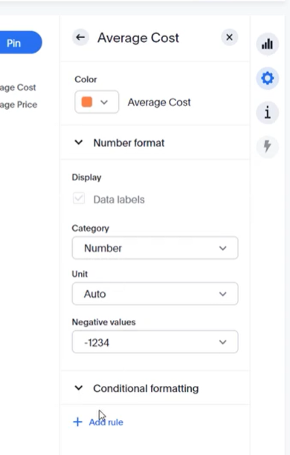

*”select an area” to zoom a problem area

## Pivot Tables

Note something new fields added to the chart doesn’t appear…goto configure and you will see t under “Not visualized” area

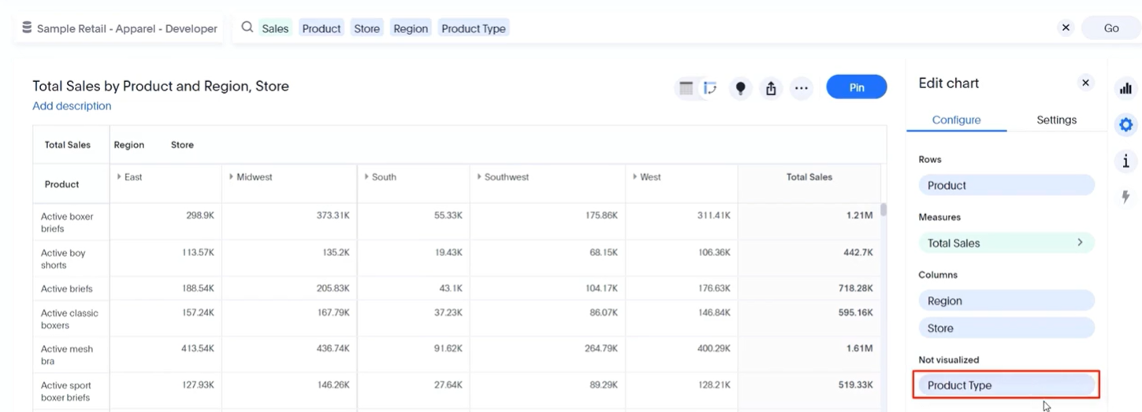

To switch to heatmap mode from pivot table

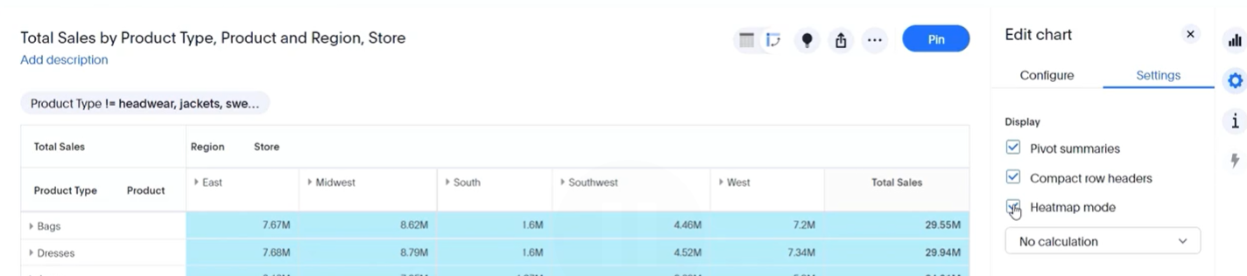

*we can also use conditional formatting

*we can change the aggregation method in settings

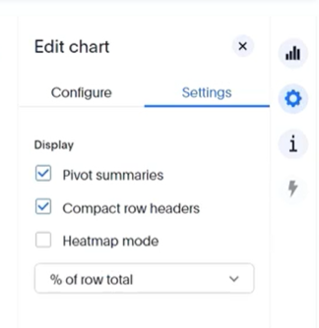

## Chart Customization Quiz

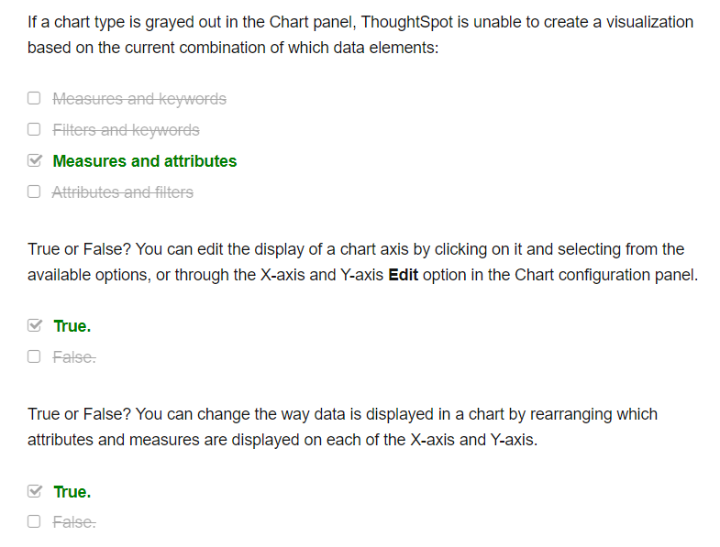

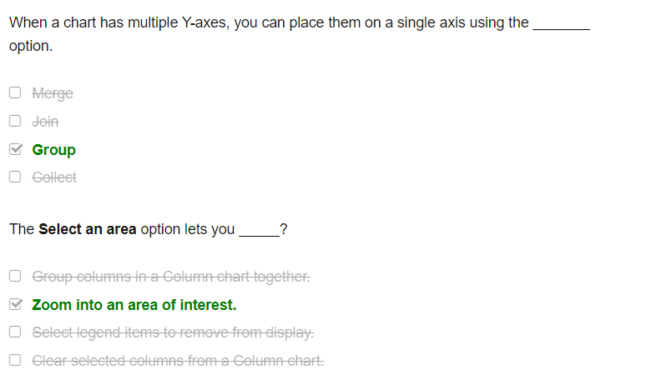

# 7.Sharing

* Learn how to share objects
* Learn how to set sharing permissions
* Learn how to schedule Liveboard sharing

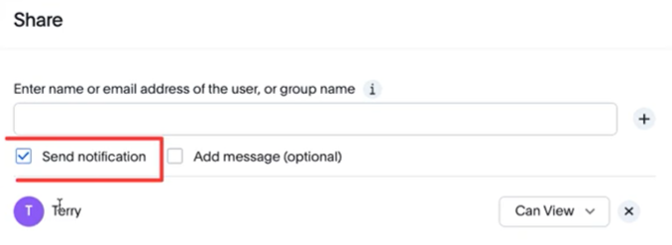

* By default, only you and administrators can see your objects.
* User gets email by default when shared
* Can view and can edit option

## Scheduling Liveboards

* Three dots > manage schedules
* Then add schedule
* 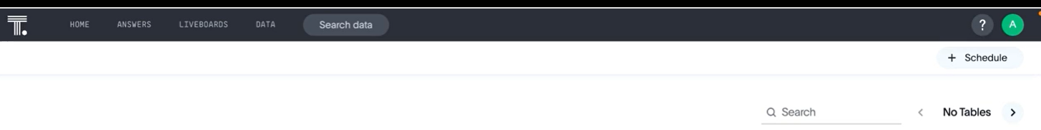
* Gating condition

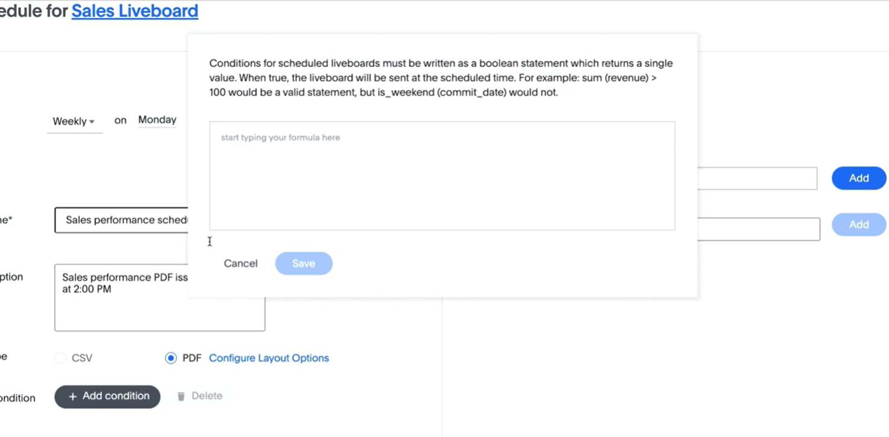

## Scheduling quiz

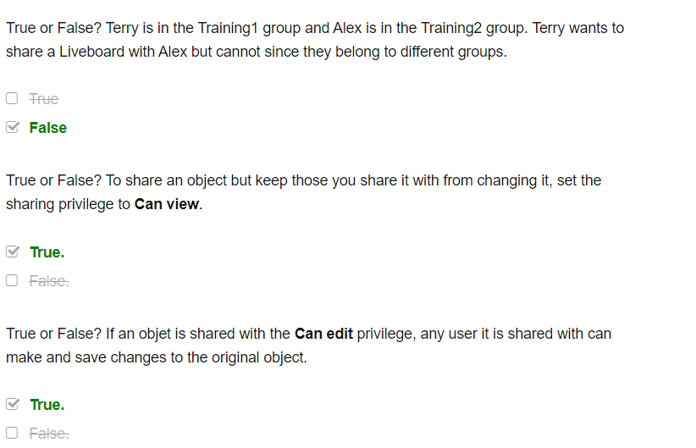

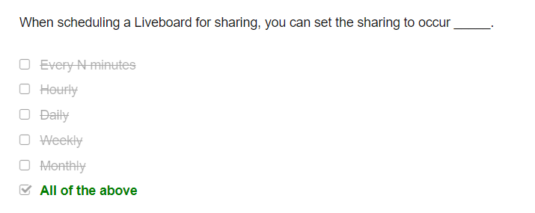

# Links

Learning path : [Welcome to ThoughtSpot Cloud](https://training.thoughtspot.com/welcome-to-thoughtspot-cloud)

Docs : [ThoughtSpot Software Documentation | ThoughtSpot Software Documentation](https://docs.thoughtspot.com/software/latest/)

# Question

1. Is there options in answer to pick saved results and not real time results of backend data?
2. Direct excel connection – yes under data> tables
3. Unstructured data as source? No, snowflake variant data type needs to be convedrted to table format to be read..or view in snowflake
4. Watchlist?
5. How to create tile? –use one measure, select column summary from settings and pin the summary, not the answer/search
6. When I apply filter from answers, will the attribute that is being pulled into the answer is the only ones that I can use filter on?
7. When using layered condition for measure, can we change the “AND” and “OR” criteria
8. How to do window function?using group_aggreate (column level aggregate)
9. Will changing the order of columns change the viz of the columns
10. After adding a answer to pinboard, can user dynamically change measyre from sales on the chanrts to profit?
11. How does synonym of search work? Say crew and resource can be meant as same..how can we define that..yes, it can be defined comma separated
12. How to trigger a dashboard upon data completion
13. Is it possible to refrain by downloading the data details from a shared answer?
14. Will all answers be present in a paren folder. Can admins organize by folder strucute, by finance or by operations?
15. What version of thoughtspot is cloud? Can we use aggregate in filters?

# Things I like so far

* quick available Pareto chart
* use any attribute to quickly add a filter rather than preset attributes for filter
* drilldown base on any column(rather than preset attribute for filter) : in tableau
* Nested search (product name not in one year) present this year
* When the horizontal scroll is applied on the chart, y-axis adjust as we scroll
* (Number format of labels and axis are maintained separately)
* When the horizontal scroll is applied on the chart, y-axis adjust as we scroll
* Number format of labels and axis are maintained separately

## Tableau vs. Thoughtspot

*multiple y-axis, use group in TS vs. combine acis in tableau..more than 2 meeasure be combined in thoughtspot?

*gating condition while scheduling in TS – same as don’t send report when empty?

* 
* Gating condition before scheduling the dashboard (like only when sales drop below $1M send the dashboard)
* Pause schedule possible (tableau unsubscribe and it goes away) ; options to resume and delete